I think it is better to let them install Microsoft Windows Server 2019 and Windows 10 client on their machines, in a virtual environment using VMware Workstation 16 pro.

**Setting up the virtual Lab:**

1. Download VMware Workstation 16 pro here: <https://www.vmware.com/products/workstation-pro/workstation-pro-evaluation.html>
2. VMware license key here is the link:

<https://gist.github.com/williamgh2019/cc2ad94cc18cb930a0aab42ed8d39e6f>

1. Microsoft Windows Server download here: <https://www.microsoft.com/en-us/evalcenter/evaluate-windows-server-2019>

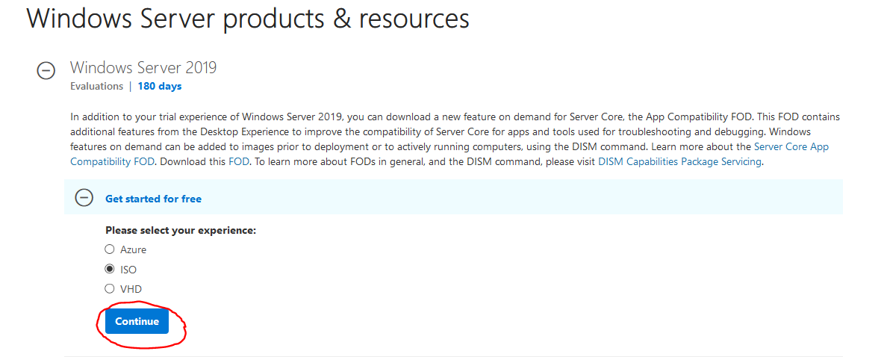

1. Windows 10 download here: <https://www.microsoft.com/en-us/evalcenter/evaluate-windows-10-enterprise>

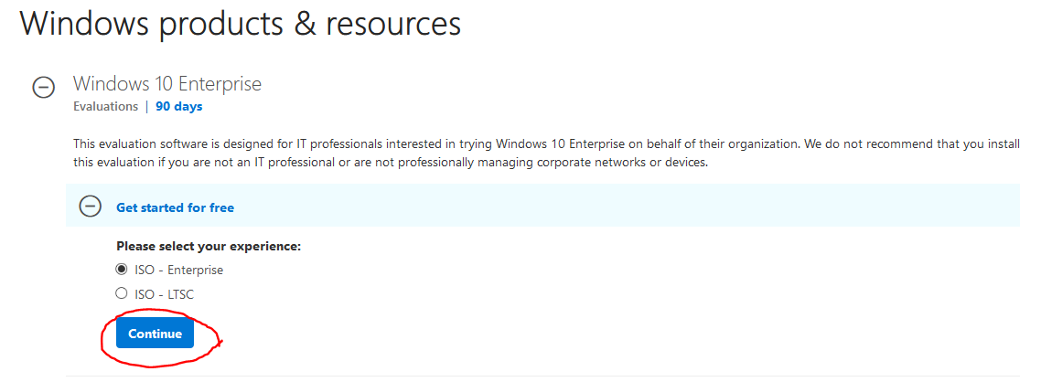

1. Install Windows Server 2019 and Windows 10 on VMware here is a link to YouTube video that will show step by step install instructions:

<https://youtu.be/OAU2cod8z2E>